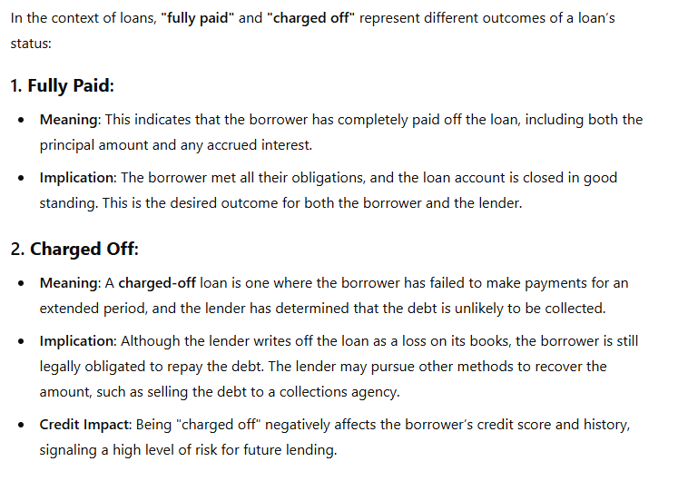

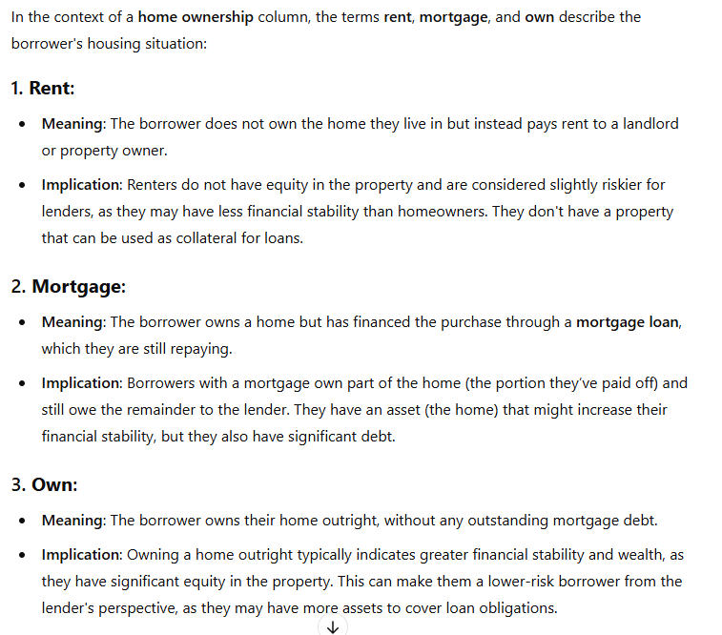

A mortgage is a loan used to purchase or maintain a home, plot of land, or other real estate. The borrower agrees to pay the lender over time, typically in a series of regular payments divided into [principal](https://www.investopedia.com/terms/p/principal.asp) and [interest](https://www.investopedia.com/terms/i/interest.asp).

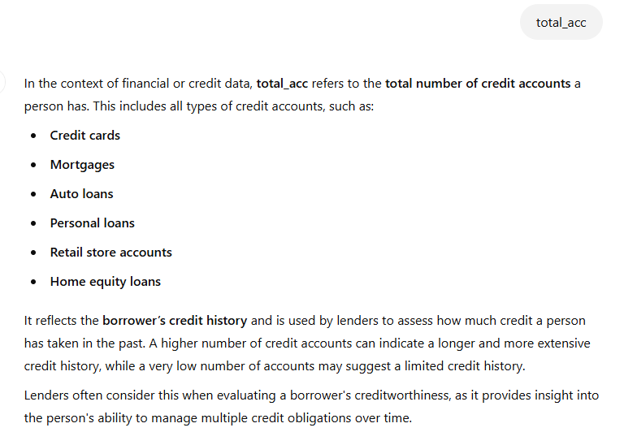

**Start**

1. Selected data and created pivot table.
2. First I want to know total loan applications but I don’t know whether id value has duplicates or not. To check that select id column, go to conditional formatting, highlight cell rules duplicate values and then sort by color.
3. Now in pivot table first for **total loan application** we pick id and then set value settings as count.

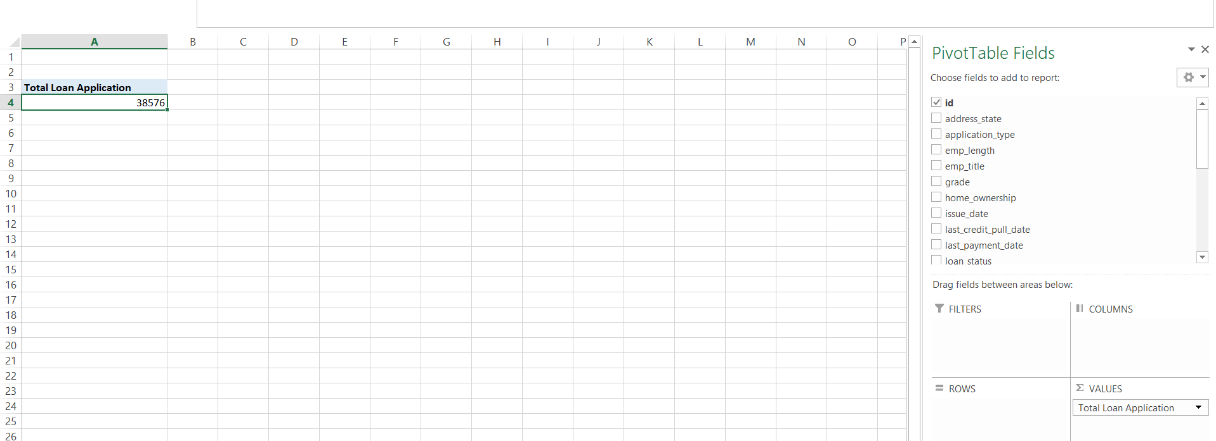

Note:   
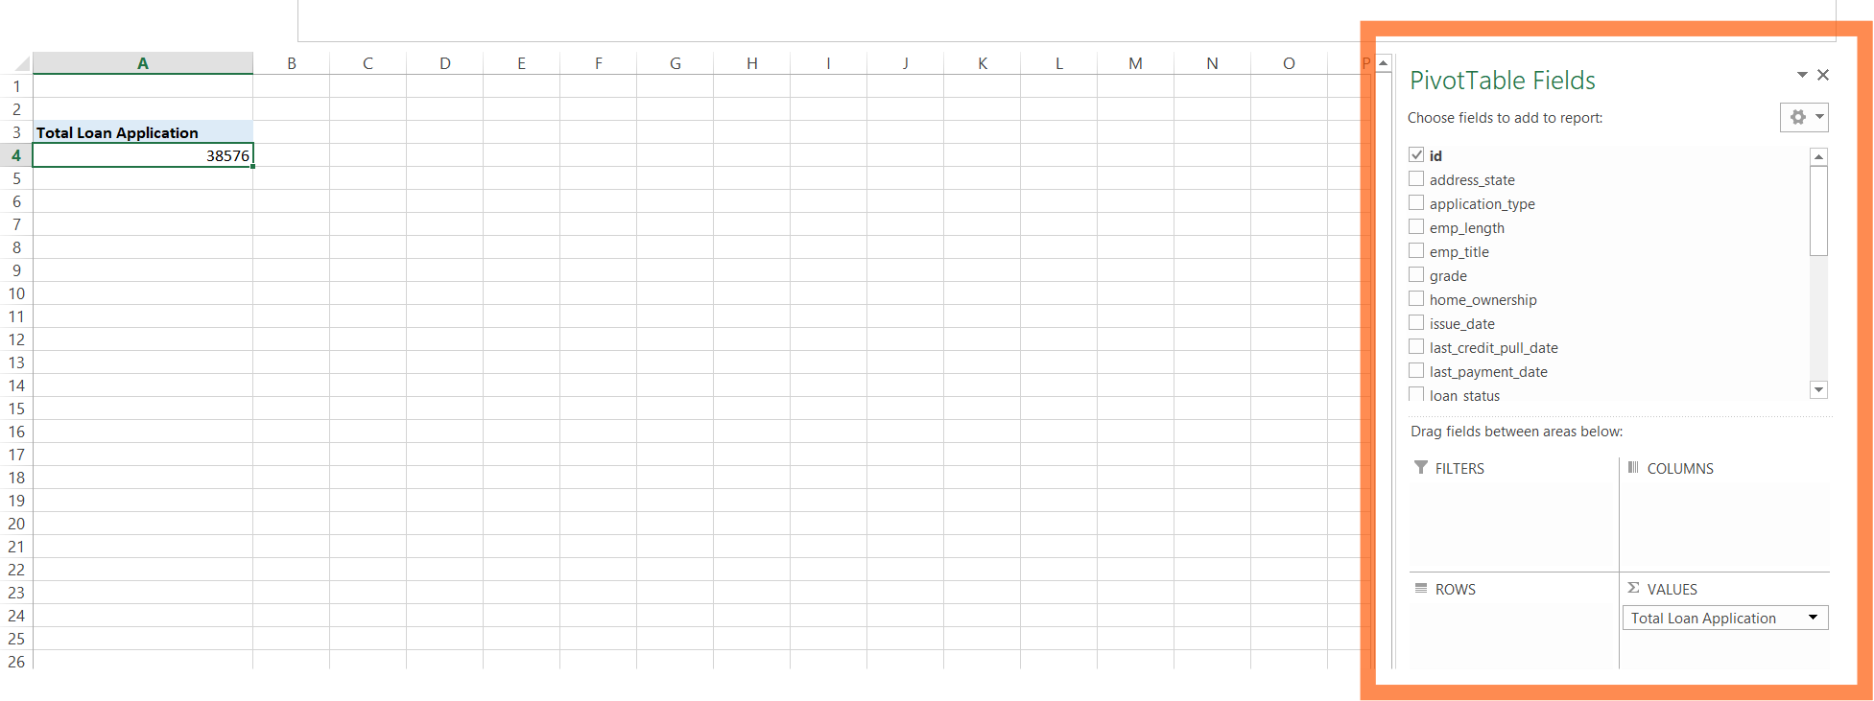  
  
if somehow it is lost, select cell “Total Loan Application”, click on analyze tab at top and then click field list.

1. Now for total funded amount (amount given by bank to customer) and so on. 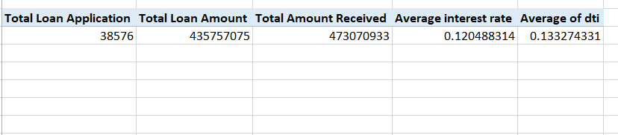
2. I want to change these values as 38.5k, 435.7M and so on. For that go to that cell, press right click

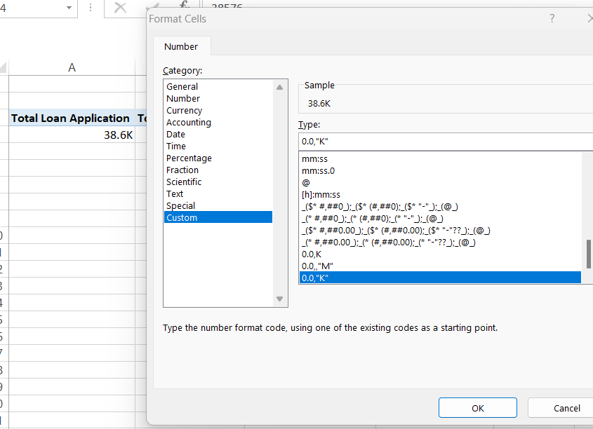

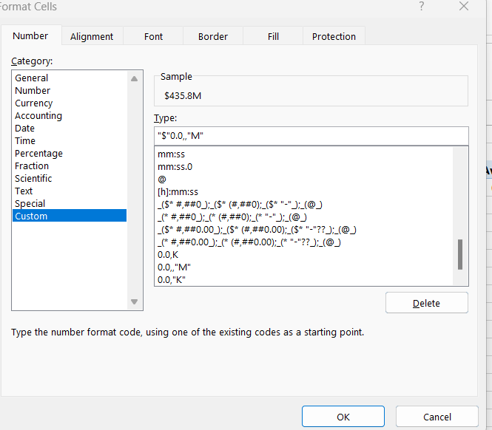

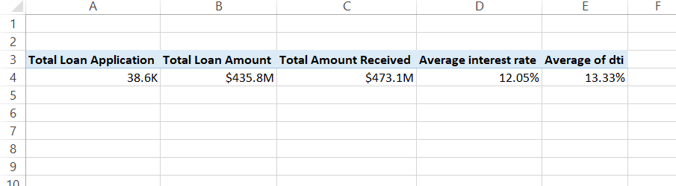

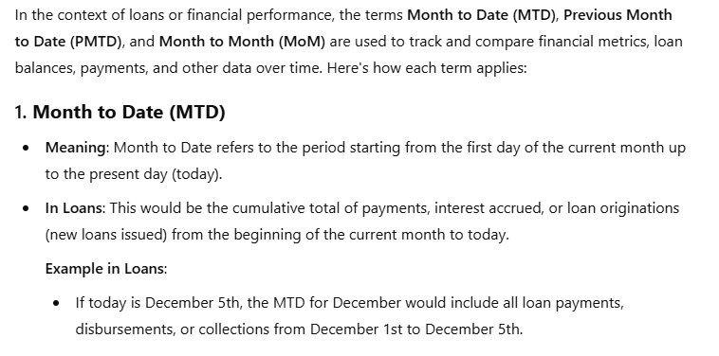

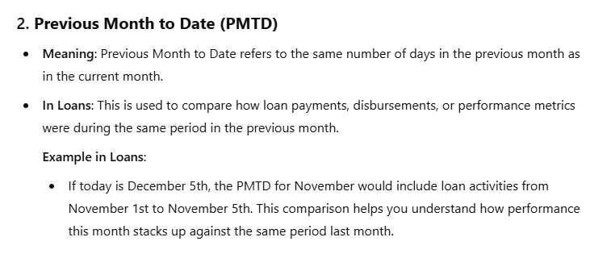

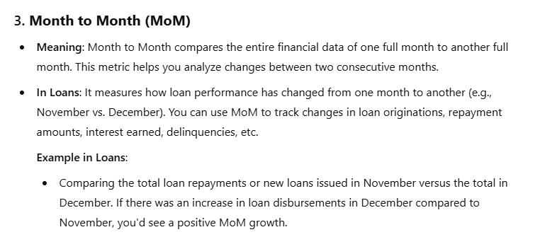

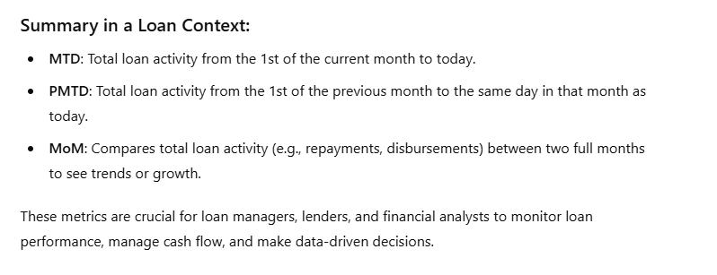

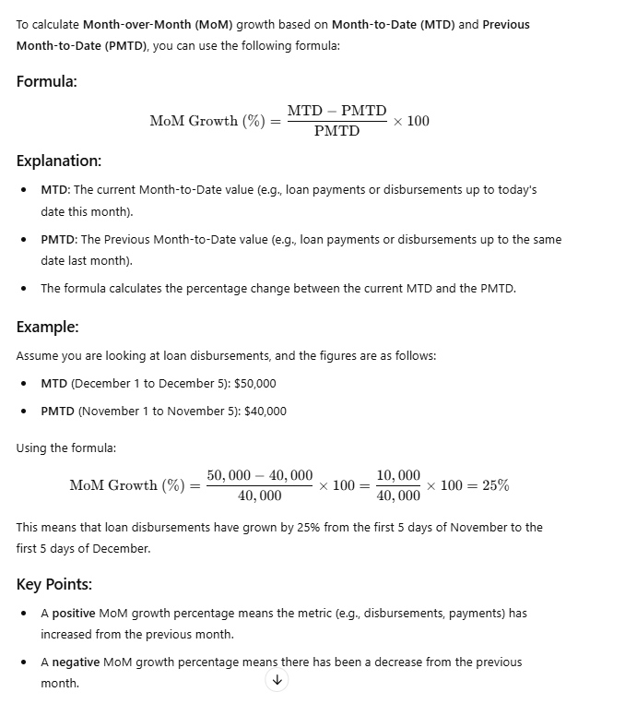

1. I have following type of date format, I want all in one, when I do by custom in data type it is not happening.   
   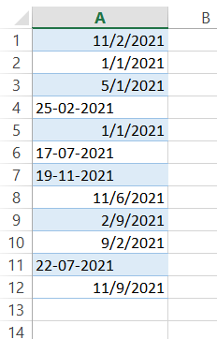  
     
   So for that select the cells, go to data tab and text to column, tick delimeted, and in next don’t tick any option go to next and then click in date and set format there.   
   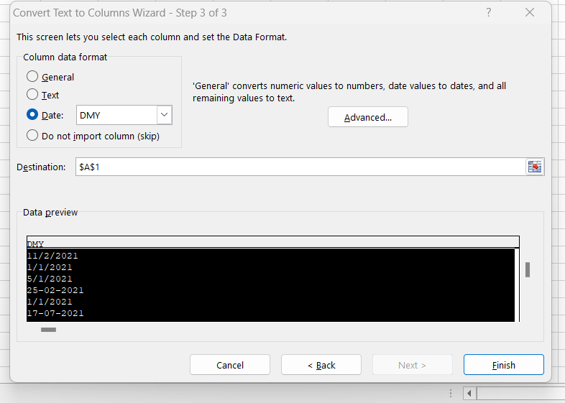  
     
   Press finish and job done. If changes is not reflected while making pivot table, go to that analyze tab and then refresh.  
   Sort it.  
     
   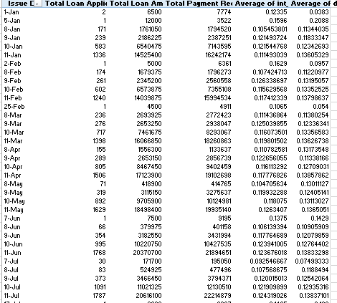

Select Jan dates, and then group the, and similar for others.

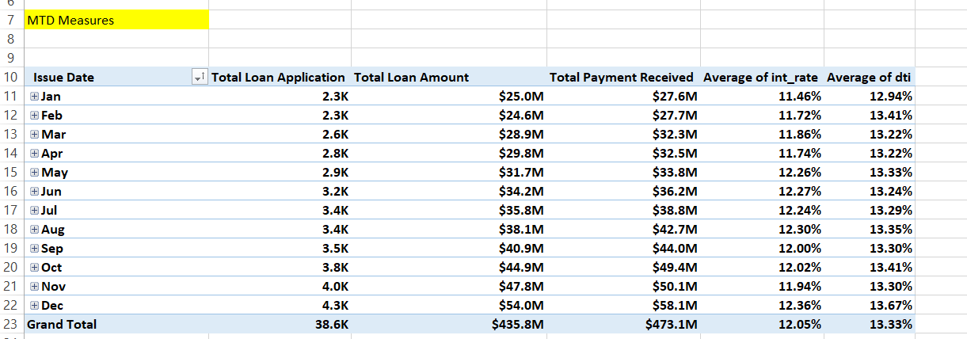

We don’t need grand total, right click and remove it. Or go to analyze and remove it.

Select only December month.

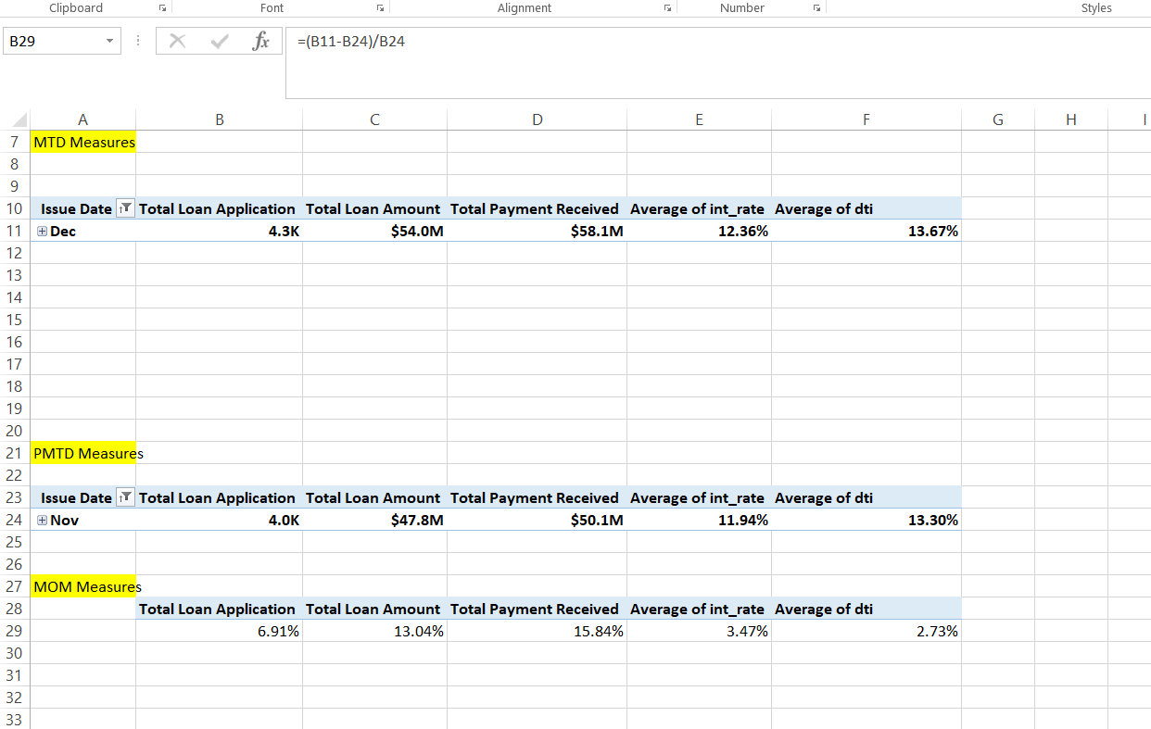

**Now we create first Dashboard**

Open new tab. Select all and then fill a color. Create a new shape and then adjust height and width.

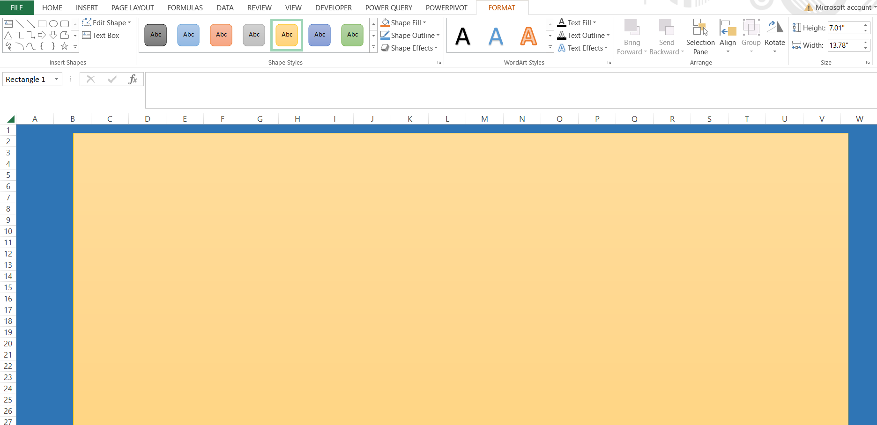

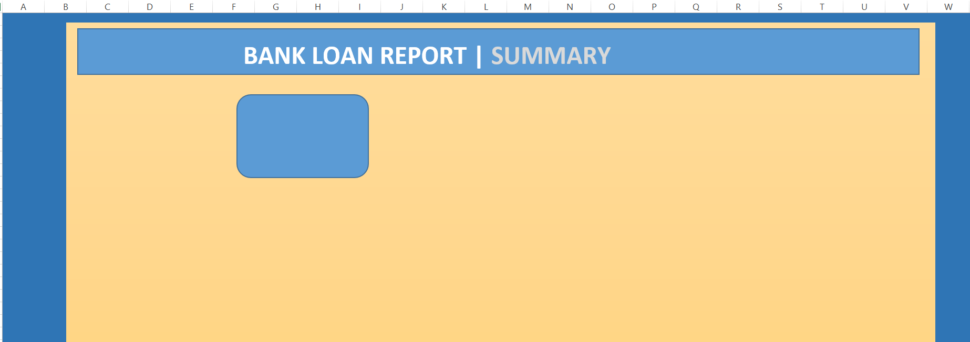  
 **Now we bring our calculations.  
  
First intert text box in that blue box and write “Total Loan Applications”**

**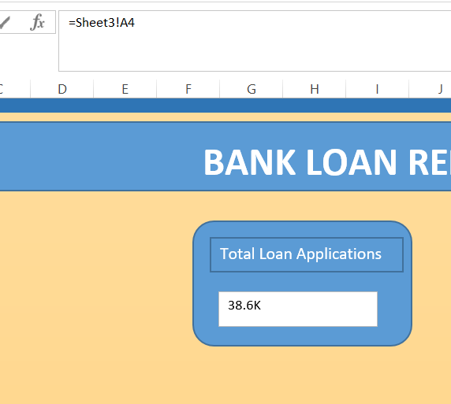  
  
If it doesn’t come directly and you get error   
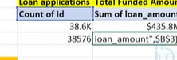  
  
Just copy value in another cell.**

**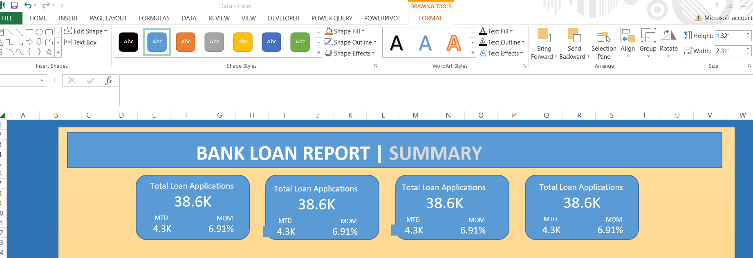  
  
To alogn value select all shapes and go to align and select “distribute horizontally” and “Align Middle”.**

**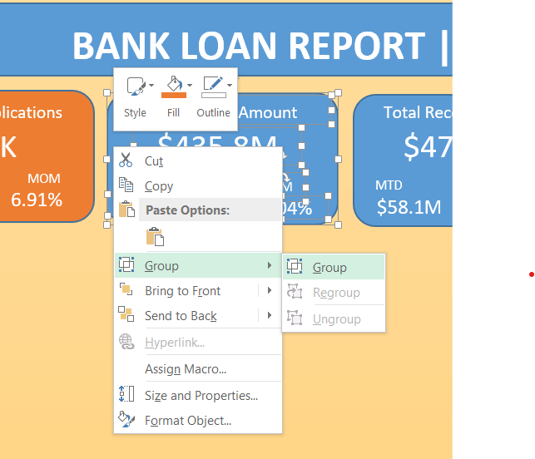  
  
If you group you can mode all at once.  
  
To select value you need to select two times, I mean two times left click.**

**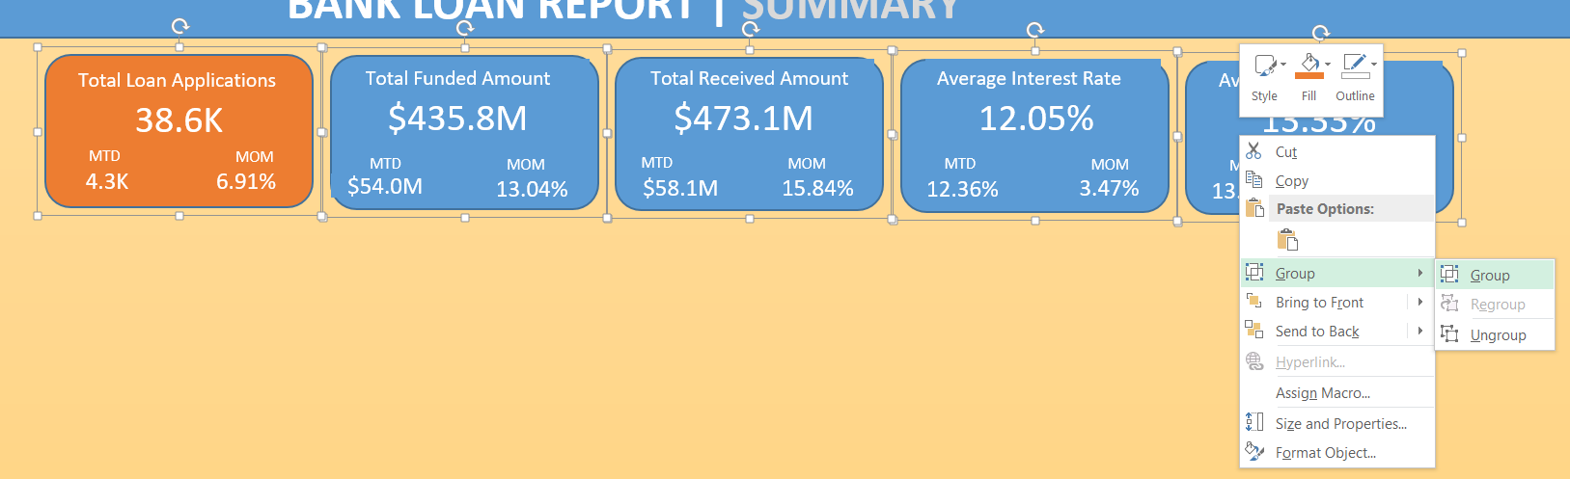  
  
Again grouping from outside.**

**Now Good Loans**

For that we create a new column in original data called “Good vs Bad Loans”

=IF(OR([@[loan_status]]="Fully Paid", [@[loan_status]]="Current"),"Good Loan",IF([@[loan_status]]="Charged Off","Bad Loan",""))

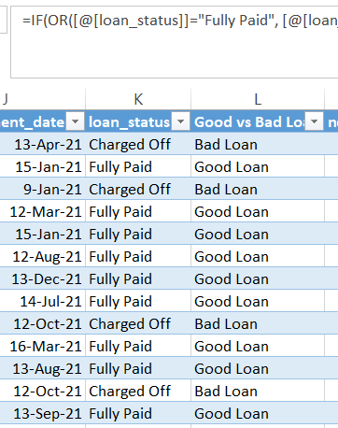

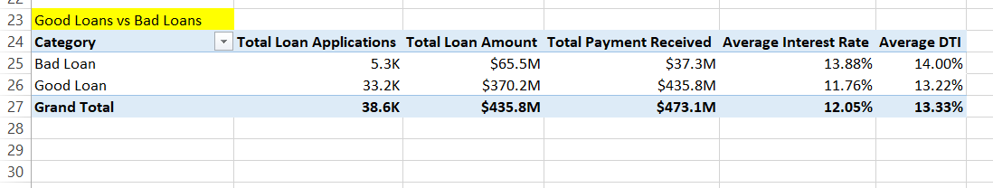

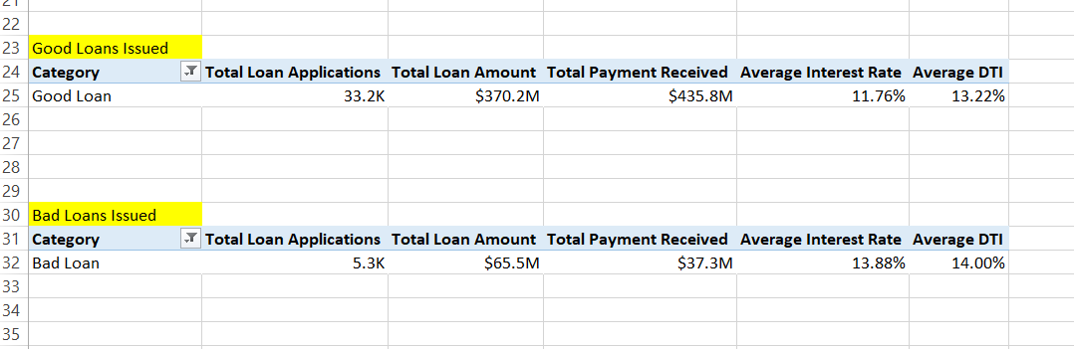

**If you want to check using slicer, go to insert and select slicer, right click slicer and choose “report connection”**

**Note:  
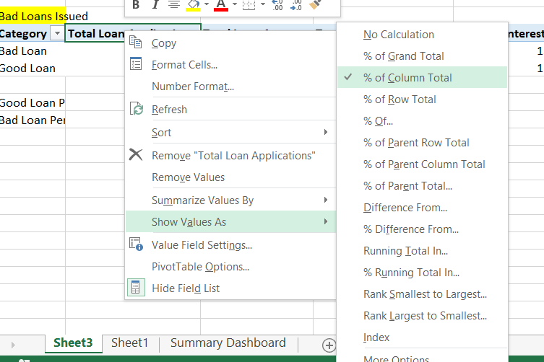**

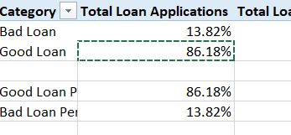

**Now we create donut chart for this.**

**For donut chart go to insert, select donut chart, and then select data, choose whole at once, both rows and both columns.  
In format, choose no fill, choose colors…**

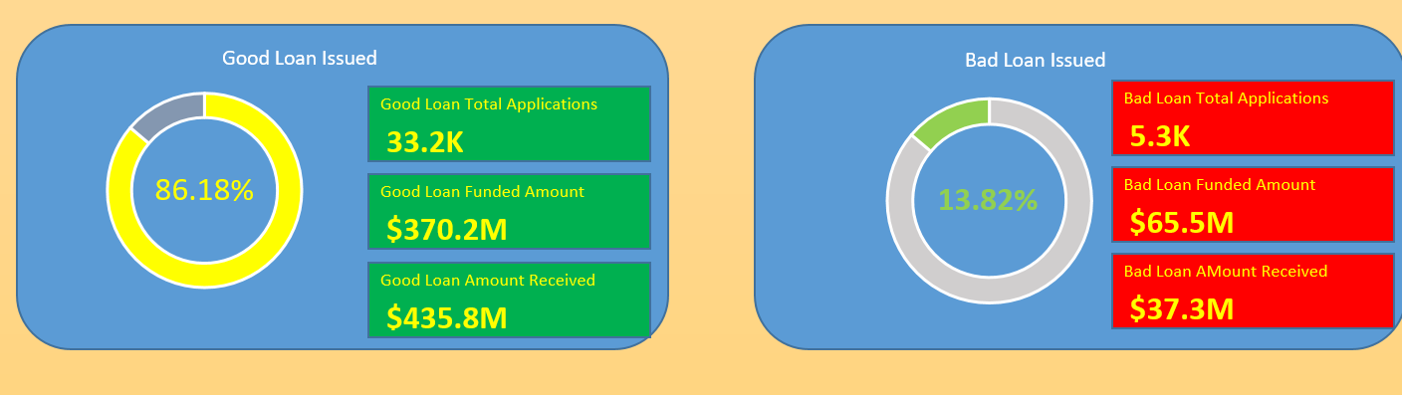

**From here we can see, good loan are more than bad loans. But 13% of bad loans is also big value. Profit is there in good loans, but loss in bad loans.**

**Now we create loan status**

**How many are fully paid, charged and current. We can do this by help of bar chart.**

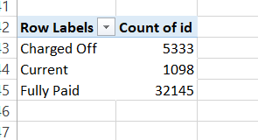

**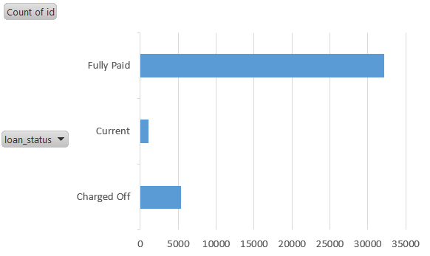  
  
Right click “Hide all field buttons”.**

**To remove those grid lines you can double click on those lines and press delete.**

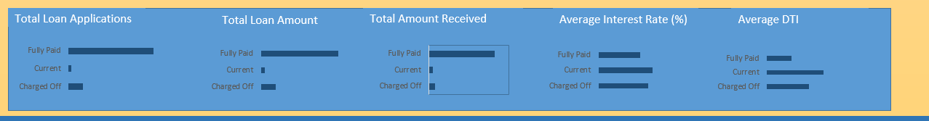

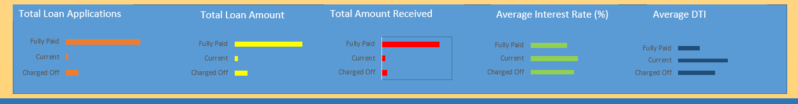

**To change size of bar,  
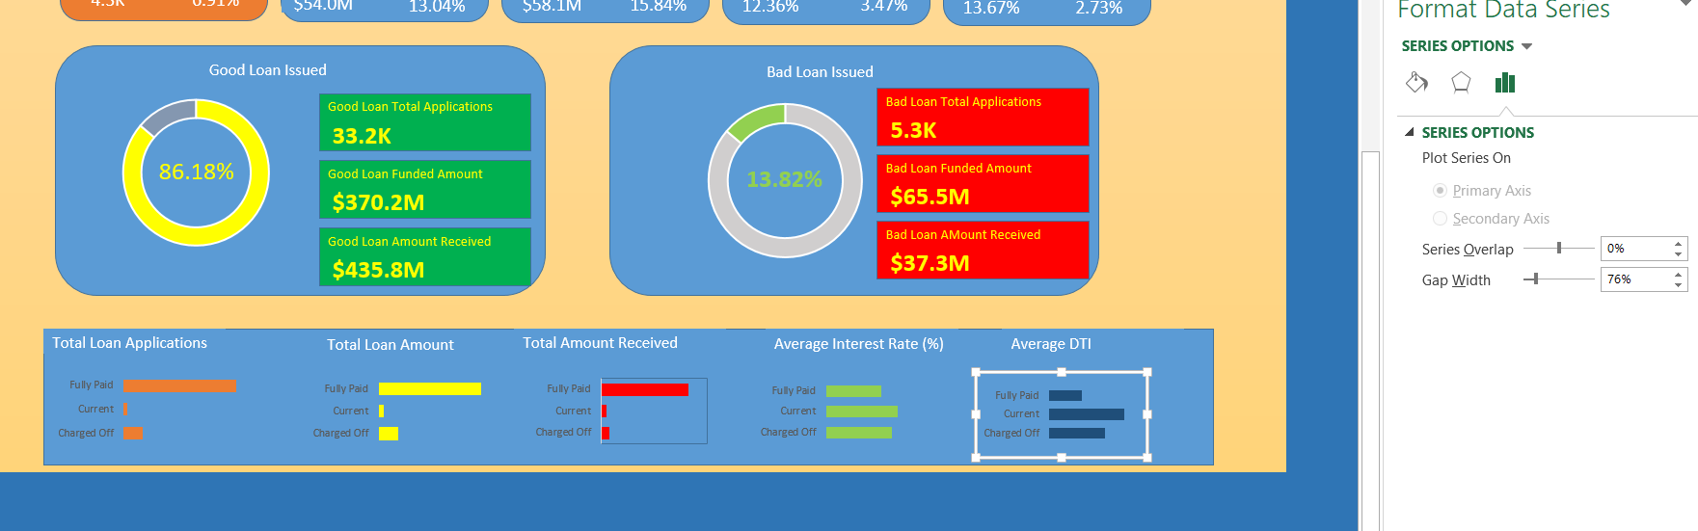**

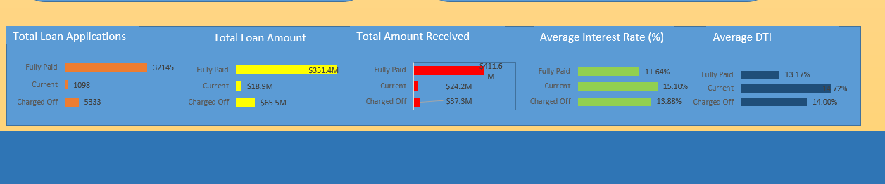

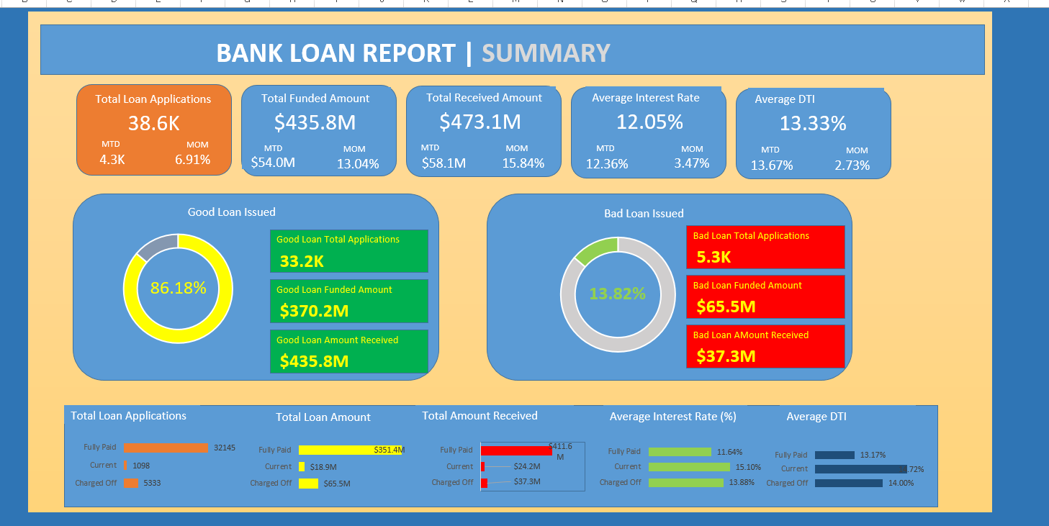

**Overview Dashboard**

**Monthly Trend By Issue Date:**

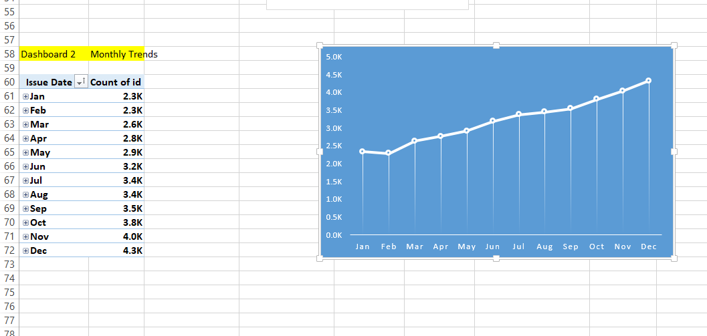

**Now we create state chart  
For map  
  
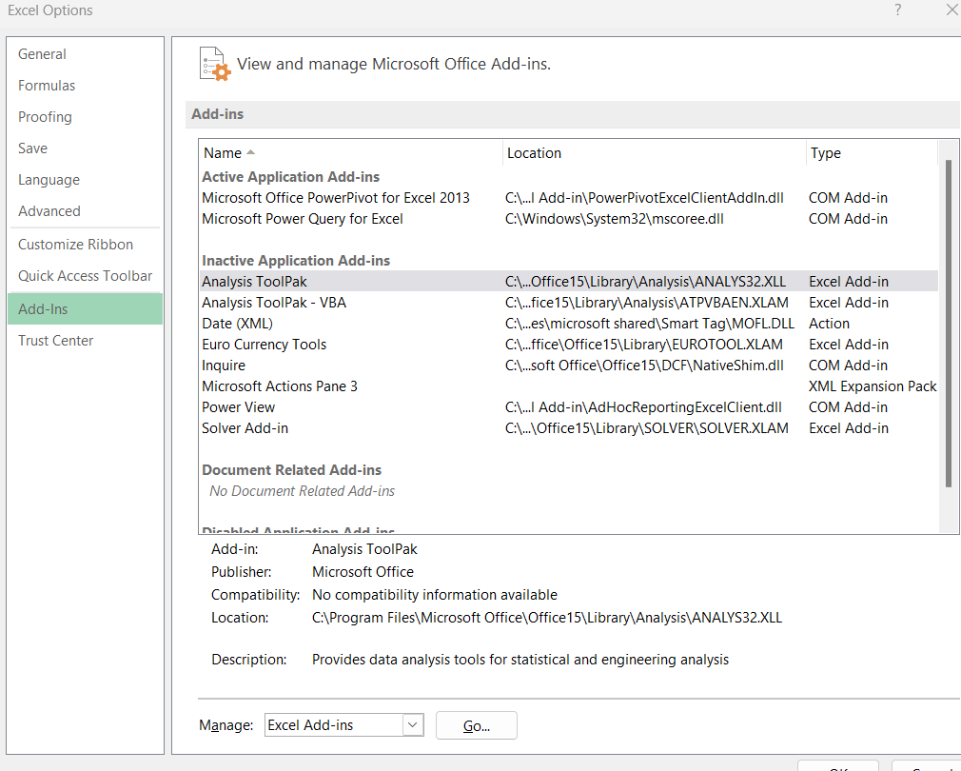**

**No map chart so skipped**

**Now we create term analysis**

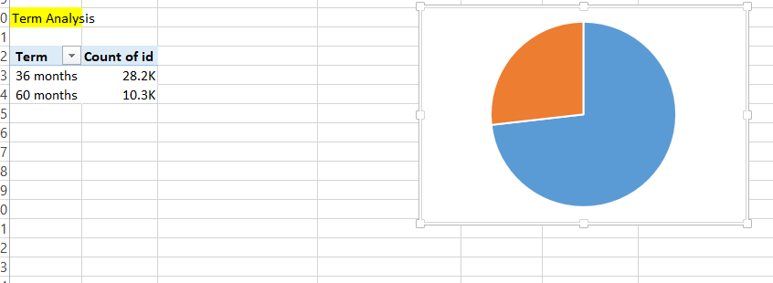



**If this happens right click and then bring to front.**

**Now we create Employee Length Analysis**

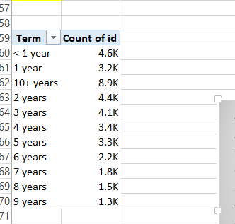

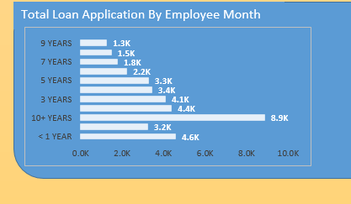

**Now we create on basis of purpose.**

**And similarly on basis of home ownership  
  
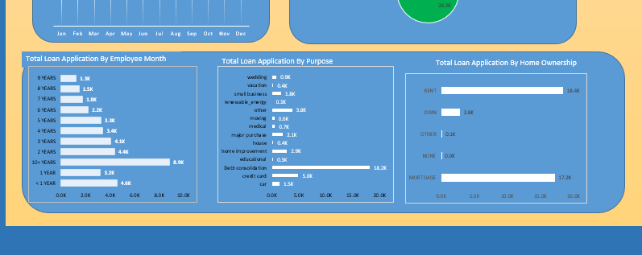  
  
On basis of home ownership our plan was to create tree map, but its not available.**

**Now create slicer**

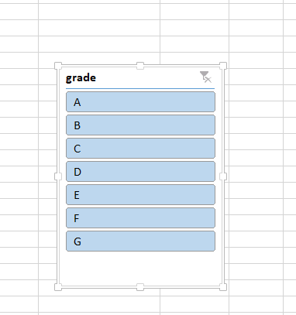

**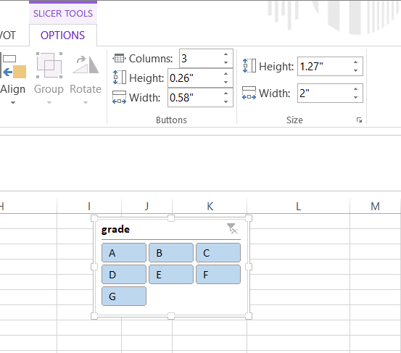  
  
Made columns value as 3.**

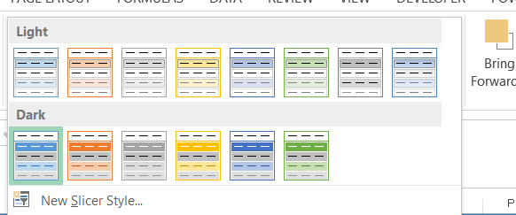

**Go to new slicer style**

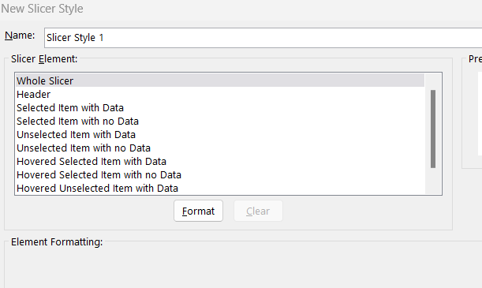

**Click on whole slicer and format.**

**In fill you choose the color that you want….**

**Then click ok.   
Now again choose header, and then format it**

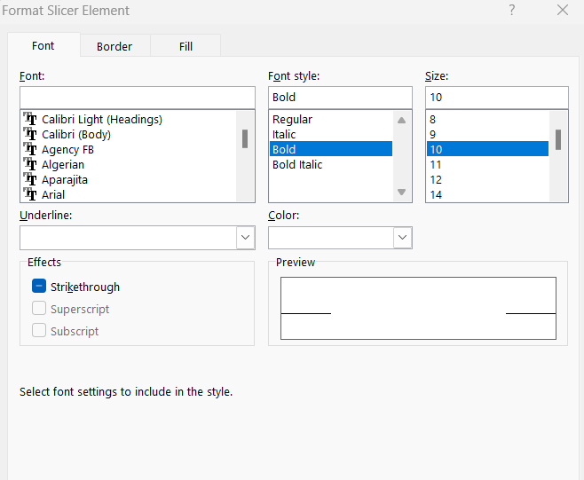

**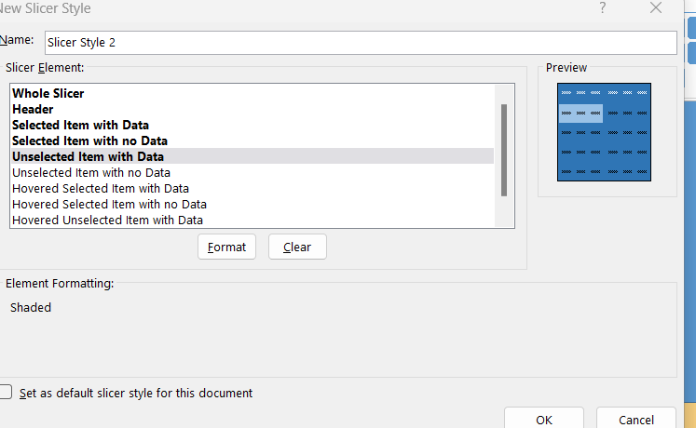  
  
I have formatted those 5 at top. Now click ok. Now you see no change.**

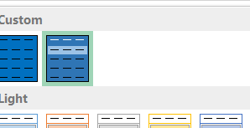

**Now right click on slicer, choose report connection and then tick all.**

**Now we create another slicer called purpose.**

**Now we will add navigation button**

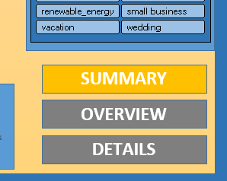

**Simple text box and written and filled color.**

**Now right click on first text box (Summary), select hyperlink**

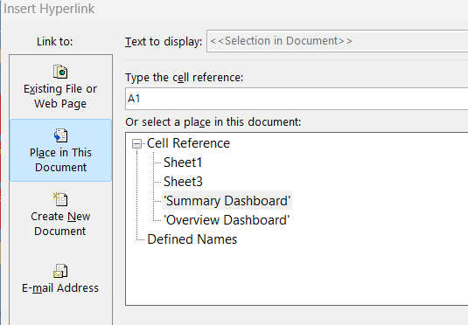

**And then choose accordingly and place okay.**

**For details we placed sheet 1 which is actual data (original)**

**Final Dashboard**

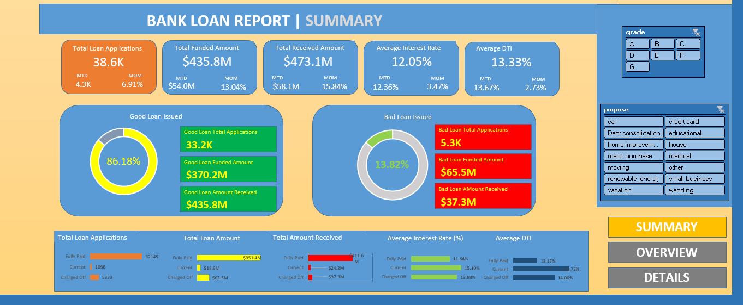

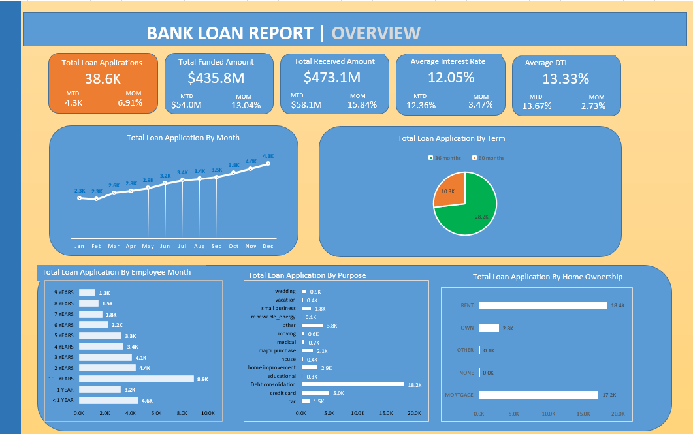

**Our Final Dashboard is Created**

